Welcome to our Data Science Meetup with the courtesy of Facebook Developer’s Circle Islamabad.

This Session is oriented towards equipping you with the knowledge of programming languages & using them for advance tasks. For the time being, we will be using Python & its implementation for Data Cleansing so it can be further processed for Modelling, Visualization or Producing insight according to the use case.

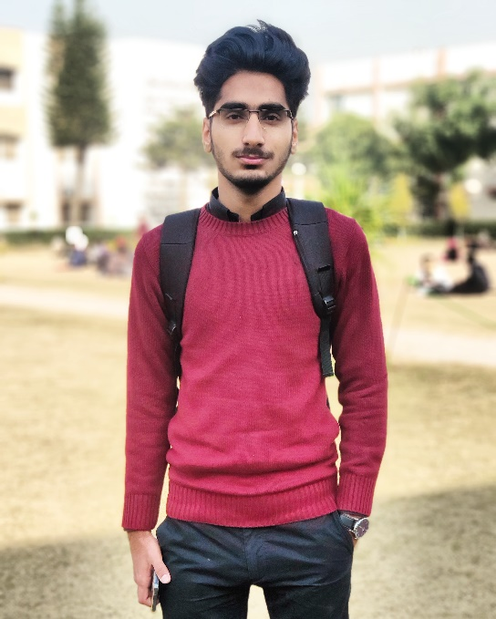

**Usman Khan**

**About the Speaker:**

Machine Learning Enthusiast working & researching In the domain of Natural Language Processing. DevC Scholar & Facilitator for Facebook’s Developer Circle’s Data Science Track. Associated with Winx Technologies & Young’s Pvt Ltd. Moreover, a Student of Computer Science from National University of Modern Languages, Islamabad.

**Agenda:**

* Why Python?
* Why Data Cleaning?
* Methodologies for Data Cleansing
* Hands-on Workshop on python
* Hands-on Workshop on Cleaning the data
* Concluding Remarks

**Workshop Details:**

* Completing the Perquisites
* Hello World Program in Python
* Basic Work flow of python
* Getting the Dataset for processing
* Analysing the Data
* Applying Different Methodologies for Multiple Use Case Scenarios
* Concluding the workshop
* Additional: Some NLP tricks for text.

**Pre-Requisites:**

* Anaconda3 (This Contains the entire Package including numpy,pandas and many other useful resources)
* Python 3.7
* After installing python/anaconda, type the following lines in the CMD

pip install pandas

pip install numpy

That’s it. You’re good to go.